**Program 1: Write a program for shopping in C++, in which there are two users (admin and user). Admin can update product price and User can only buy these product.**

Sample output:

For Admin:

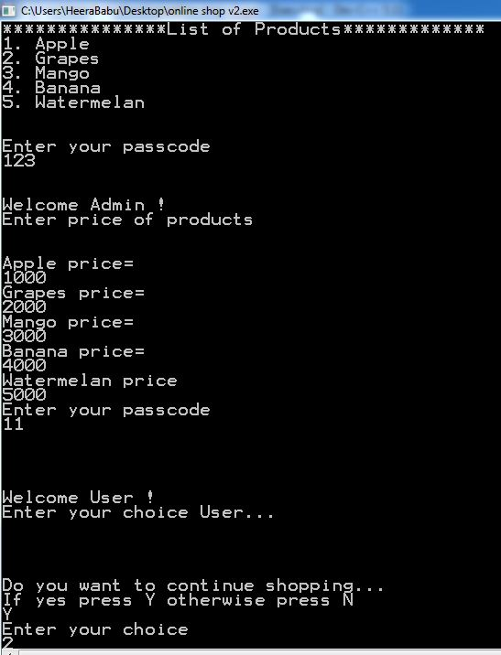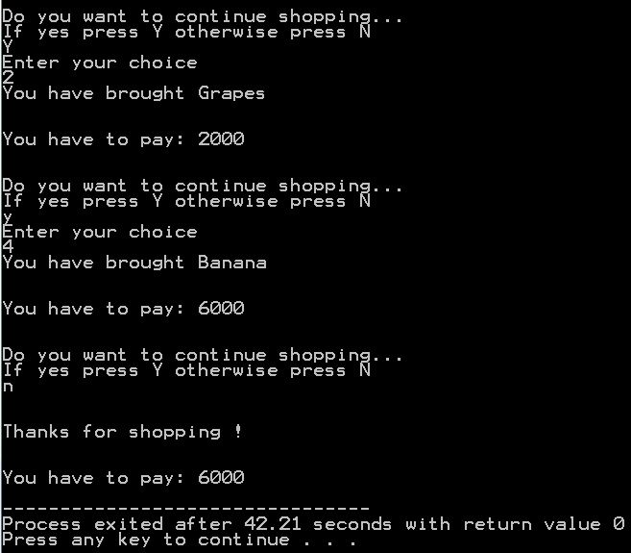

**General User:**

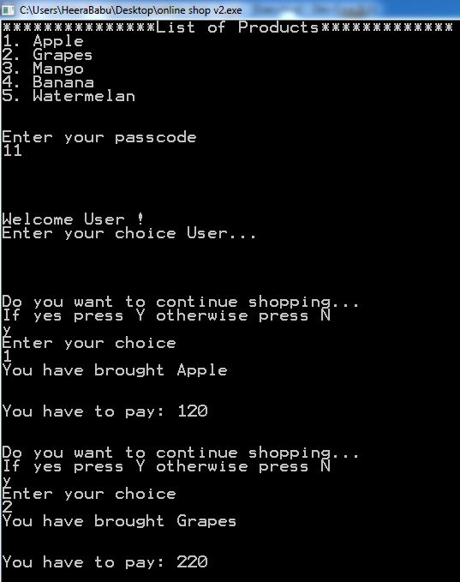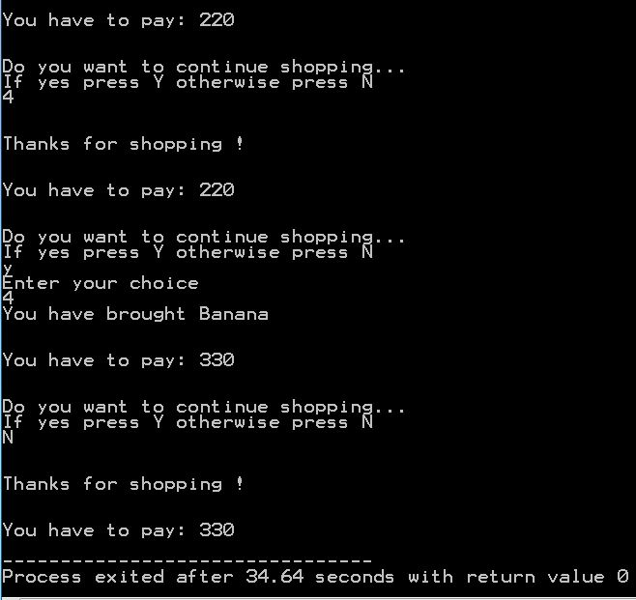

**Program code:**

//use header files

#include<iostream>

**using** **namespace** std**;**

//define main function

int main**()**

**{**

//define variables and initialized it so that

//no garbage value will it contain

int TotalPrice**=**0**;**

int TotalDiscount**=**0**;**

int passcode**;**

//initialize product price for User login

int price1**=**120**,** price2**=**100**,** price3**=**140**,** price4**=**110**,** price5**=**110**;**

cout**<<**"***************List of Products*************"**<<**endl**;**

cout**<<**"1. Apple"**<<**endl**;**

cout**<<**"2. Grapes"**<<**endl**;**

cout**<<**"3. Mango"**<<**endl**;**

cout**<<**"4. Banana"**<<**endl**;**

cout**<<**"5. Watermelan"**<<**endl**;**

cout**<<**endl**<<**endl**;**

// define a floor level for goto

floor1**:**

//define a credential for login user and admin

cout**<<**"Enter your passcode"**<<**endl**;**

cin**>>**passcode**;**

cout**<<**endl**<<**endl**;**

**if(**passcode**==**123**)**

**{**

// if admin login then update product detail

cout**<<**"Welcome Admin !"**<<**endl**;**

cout**<<**"Enter price of products"**<<**endl**;**

cout<<endl<<endl;

cout<<"Apple price="<<endl;

cin>>price1;

cout<<"Grapes price="<<endl;

cin>>price2;

cout<<"Mango price="<<endl;

cin>>price3;

cout<<"Banana price="<<endl;

cin>>price4;

cout<<"Watermelan price"<<endl;

cin>>price5;

//if price updated then go to again login

goto floor1;

}

else

{

//if user login

cout<<endl<<endl;

cout<<"Welcome User !"<<endl;

cout<<"Enter your choice User..."<<endl<<endl<<endl;

int choice;

do

{

//make repetive statement if user buy a product

//then again shopping alert !

cout<<endl<<endl;

cout<<"Do you want to continue shopping..."<<endl;

cout<<"If yes press Y otherwise press N "<<endl;

char confirm;

cin>>confirm;

if(confirm=='y' || confirm=='Y')

{

//make switch with multiple product

cout<<"Enter your choice"<<endl;

cin>>choice;

switch(choice)

{

case 1:

{

cout<<"You have brought Apple"<<endl;

//update TotalPrice in each case same

TotalPrice = TotalPrice+price1;

break;

}

case 2:

{

cout<<"You have brought Grapes"<<endl;

TotalPrice = TotalPrice+price2;

break;

}

case 3:

{

cout<<"You have brought Mango"<<endl;

TotalPrice = TotalPrice+price3;

break;

}

case 4:

{

cout<<"You have brought Banana"<<endl;

TotalPrice = TotalPrice+price4;

break;

}

case 5:

{

cout<<"You have brought Watermelan"<<endl;

TotalPrice = TotalPrice+price5;

break;

}

default:

{

cout<<"Kindly choose correct item !!"<<endl<<endl;

}

}

}

else

{

//if user doesn't want to continue shopping

cout<<endl<<endl;

cout<<"Thanks for shopping !"<<endl;

}

//after shopping finish

cout<<endl<<endl;

cout<<"You have to pay: "<<TotalPrice<<endl;

choice ++;

}

while(choice<=5); //end of loop with no of cases

}

}